A

Project Report on

**INVENTORY MANAGEMENT SYSTEM**

Submitted in partial fulfillment of completion of the course

**Advanced Diploma in IT, Networking and Cloud**

Submitted by:

**SHIVLAL PRASAD AZAD**

**SURAJ KUMAR**

**SOVIK DUTTA**

**RAJU**

Under Guidance of:

**ARPITA ROY (Edunet)**

**SAYANTI MANNA (Edunet)**

**  **

Year 2023

**Abstract**

Inventory management is a critical aspect of supply chain operations for businesses of all sizes and industries. Efficient inventory management not only ensures product availability to meet customer demand but also impacts a company's profitability. This abstract provides a brief overview of key concepts and strategies in inventory management, highlighting the importance of adopting modern technology and data-driven approaches to optimize inventory levels, reduce carrying costs, and enhance overall operational efficiency.

Effective inventory management involves several key components:

1. **Demand Forecasting**: Accurate demand forecasting is the foundation of inventory management. Utilizing historical data, market trends, and predictive analytic helps businesses anticipate customer demand, reducing the risk of overstocking or stock outs.

2. **Safety Stock**: Maintaining a safety stock helps cushion against unexpected demand spikes or supply disruptions. However, it's crucial to strike a balance.

3. **Inventory Turnover**: Measuring inventory turnover helps assess how efficiently a company is utilizing its resources. Higher turnover rates indicate efficient inventory management, while lower rates may suggest excess or obsolete stock.

4. **Just-in-Time (JIT) Inventory**: JIT principles involve minimizing inventory levels by receiving goods only as needed. This approach reduces carrying costs and frees up capital that can be invested elsewhere.

5. **Inventory Tracking and Technology**: Implementing advanced inventory management software and technologies, such as RFID and Io T sensors, allows real-time tracking and improved visibility into stock levels, aiding in decision-making.

6. **Supplier Collaboration**: Collaborating closely with suppliers can lead to more accurate lead times, better order quantities, and reduced stock outs. Communication and transparency in the supply chain are essential.

7. **Data Analytic**: Leveraging data analytic and machine learning can provide valuable insights into inventory trends, helping businesses make informed decisions about procurement, stocking levels, and pricing strategies.

In conclusion, efficient inventory management is crucial for optimizing supply chain performance, reducing costs, and enhancing customer satisfaction. Businesses must adapt to the evolving landscape of inventory management by integrating advanced technologies and data-driven approaches into their strategies. This abstract serves as a foundation for understanding the importance of effective inventory management and sets the stage for exploring the intricacies and nuances of this critical business function.

**Acknowledgement**

We would like to express our sincere gratitude to all those who have supported and contributed to the successful completion of this project. Your assistance and encouragement have been invaluable throughout this journey.

First and foremost, we want to thank my project supervisors, Arpita Roy(Edunet) and Sayanti Manna(Edunet), for their guidance, expertise, and unwavering support. Their insights and feedback have been instrumental in shaping the direction of this project.

We would also like to extend my appreciation to my fellow classmates who provided valuable input, shared resources, and engaged in stimulating discussions that enriched the project. Your collaborative spirit was a driving force behind our achievements.

Furthermore, we want to acknowledge our friends and family for their patience, understanding, and encouragement throughout this endeavour. Your support provided the motivation we needed to see this project through to its completion.

Last but not least, we are grateful to the entire faculty and staff of NSTI Howrah for providing a conducive learning environment and the necessary resources to undertake this project.

This project has been a rewarding learning experience, and we are thankful for the collective efforts of everyone involved. Your support has been instrumental in making this project a reality.

Thank you all for being a part of this journey.

Shivlal Prasad Azad, Suraj Kumar,

Sovik Dutta

NSTI Howrah

04/09/2023

**TEAM COMPOSITION AND WORKLOAD DIVISION**

The team composition for the "Inventory management system" project can vary depending on the project's complexity, goals, and scope. This is the team composition:

1. Shivlal Prasad Azad (Project Leader): Responsible for overseeing the project's planning, execution, and delivery, coordinate tasks, manage timelines, and ensure that the project stays on track and documentation.

2. Suraj Kumar (Web Developer): Responsible for designing and building the website, back-end development tasks, including coding, testing, and deployment. The team may consist of:

* Back-end Developers: Responsible for building the server-side logic, managing databases, and implementing authentication and authorization.

1. Raju (Web Developer): Responsible for designing and building the website, front-end development tasks, including coding, testing, and deployment. The team may consist of:

* Front-end Developers: Responsible for creating the user interface, ensuring responsive design, and implementing client-side functionalities using HTML, CSS, and JavaScript.

4.Sovik Dutta(Quality Assurance (QA) Tester): Responsible for testing the website to identify and report bugs, usability issues, and inconsistencies. They help ensure the website functions correctly and is free of errors.

**WORKLOAD DIVISION:**

The successful execution of this project was made possible by the collaborative efforts of each team member, who contributed their unique skills and insights. The workload was distributed as follows:

1. Suraj kumar :- Project Planning and Conceptualization
2. Shivlal Prasad Azad :- Back-end web developer
3. Raju :- Front-end web developer
4. Sovik Dutta :- Testing and quality assurance

All team members participated in designing various scenarios, conducting simulations, and evaluating system responsiveness.

Documentation and Report Writing:

Lead the documentation process, with contributions from all team members for their respective areas of expertise.

**Introduction to Problem**

Inventory management is a crucial component of a well-functioning supply chain and plays a pivotal role in the success of businesses across various industries. Efficient inventory management ensures that products are available to meet customer demand while minimizing carrying costs, but it's a complex task that can present numerous challenges. In this introduction, we will discuss one common problem in inventory management: excess inventory.

The Problem of Excess Inventory :

Excess inventory, often referred to as overstock, occurs when a company holds more goods or materials than it can sell or use in the near term. This issue can be particularly problematic for businesses for several reasons:

* Tied-Up Capital: Excess inventory ties up valuable capital that could be used for other critical business activities, such as investing in innovation, expansion, or marketing.
* Carrying Costs: Storing excess inventory incurs additional costs, including warehousing, insurance, security, and depreciation. These expenses can erode profit margins.
* Risk of Obsolescence: As products or materials age, they may become obsolete or lose value. This can lead to financial losses if the excess inventory cannot be sold or repurposed.
* Reduced Cash Flow: High levels of excess inventory can strain a company's cash flow, making it challenging to cover operational expenses or invest in growth opportunities.
* Inefficient Space Usage: Warehouses filled with excess inventory may lack space for new or more critical products, leading to inefficient use of storage facilities.
* Delayed Decision-Making: Excess inventory can mask underlying issues in demand forecasting, supplier management, or production planning. Delaying action to address excess inventory can compound these problems.
* Reduced Agility: A surplus of inventory can make a business less agile and responsive to market changes. It may hinder the ability to adapt to shifts in customer preferences or unexpected disruptions

**Proposed Solution**

Efficient inventory management is crucial for businesses to optimize their operations, reduce costs, and meet customer demands effectively. To address common inventory management challenges, including excess inventory, stockouts, and inaccuracies, a comprehensive solution is needed. Here, we propose a multifaceted approach to enhance your inventory management system:

1. Advanced Inventory Management Software:

Implement a robust inventory management software solution that offers real-time visibility into your inventory levels, sales trends, and supplier data. Choose a system that integrates with your other business processes, such as sales, purchasing, and accounting, for seamless data flow.

2. Demand Forecasting and Analytic :

Leverage historical sales data, market trends, and predictive analytic to improve demand forecasting accuracy. Advanced forecasting models can help you anticipate customer demands more precisely, reducing the risk of excess inventory or stock outs.

3. Safety Stock Optimization:

Implement a safety stock strategy that balances the need for buffer stock with cost considerations. Use statistical methods to calculate safety stock levels based on demand variability and lead times.

4. Training and Employee Involvement:

Invest in training your staff to understand the importance of inventory management and the tools at their disposal. Encourage employee involvement in identifying inefficiencies and suggesting improvements.

5. Data Integration and Reporting:

Integrate data from various sources within your organization and generate comprehensive reports and dashboards. These reports should provide actionable insights for decision-making.

6. Return and Excess Inventory Handling:

Develop clear procedures for handling excess or returned inventory. Implement strategies to minimize losses through discounts, returns to suppliers, or repurposing.

**Requirements**

**1. TECHNOLOGY STACK:**

* DJANGO
* For front-end view HTML,CSS,JS
* PYTHON
* User authentication and authorization

**2. HARDWARE REQUIREMENTS:**

* Developer workstations or laptops with sufficient RAM and processing power.
* Networking equipment (routers, switches) if you have an on premises test environment.

**3. SOFTWARE REQUIREMENTS:**

* Operating System: Developers can work on Windows, macOS, or Linux based operating systems.
* Code Editor or Integrated Development Environment (IDE): Examples include Visual Studio Code, Sublime Text, or JetBrains WebStorm.
* Database Management Tool: Default SQLite and more Such as pgAdmin for PostgreSQL or DBeaver for various database systems.
* Version Control: Git and a Git client or GUI tool.

**4. DEPLOYMENT ENVIRONMENT:**

* Web Server: Configure a web server (e.g., Nginx or Apache) to handle incoming requests.
* Database Server: Set up a production ready database server (PostgreSQL) with backups and redundancy.
* Backup and Disaster Recovery: Set up automated backup and recovery procedures to ensure data safety.

**USER REQUIREMENTS**

* Mobile Accessibility or PCs
* Internet Access
* Supported Browser
* Agreement to Terms

**Design Documentation**

Designing documentation for an inventory management project is crucial for its successful development and maintenance. Below, I'll outline the key components of such documentation. Keep in mind that the level of detail and complexity may vary based on the scope and scale of your project.

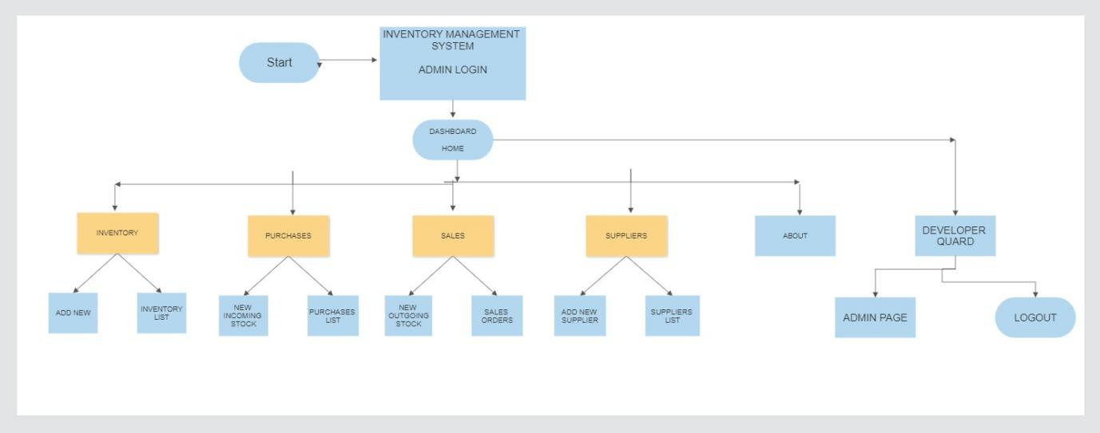

**Implementation Details**

Implementing an inventory management system involves a combination of software development, database design, hardware setup, and integration with various components. Below, I'll outline some implementation details and steps you might consider when developing an inventory management system.

1. Database Design:

Choose a relational database management system (RDBMS) like MySQL, PostgreSQL, or SQL Server.

Design the database schema based on your requirements, including tables for products, suppliers, customers, transactions, and user management.

Implement foreign key constraints and indexes for data integrity and performance.

2. Back-End Development:

Select a back-end programming language and framework such as Python with Django, Node.js with Express, or Ruby on Rails.

Develop the server-side logic for handling requests related to inventory management, authentication, and other business logic.

Implement API to allow communication between the front-end and back-end.

3. Front-End Development:

Choose a front-end technology stack like React, Angular, or Vue.js.

Develop the user interface (UI) for managing inventory, including features like adding, updating, and deleting items, as well as generating reports.

Implement user authentication and authorization for different roles (e.g., admin, manager, staff).

4. Integration:

Integrate the front-end and back-end components to create a seamless user experience.

Implement third-party integrations if necessary, such as payment gateways or barcode scanners.

5. Data Import/Export:

Develop functionality to import initial inventory data or export data for backup or analysis.

Support common data formats like CSV or Excel.

6. User Authentication and Security

Implement secure user authentication using techniques like OAuth, JWT, or session-based authentication.

Enforce role-based access control to restrict user access to specific functionality.

Implement security best practices to protect against common web vulnerabilities (e.g., SQL injection, cross-site scripting).

7. Testing:

Create a comprehensive testing plan that covers unit testing, integration testing, and user acceptance testing.

Use testing frameworks and tools to automate testing where possible.

Perform load testing to ensure the system can handle peak loads.

8. Deployment:

Choose a hosting environment (e.g., cloud-based, on-premises) and set up the necessary infrastructure.

Configure the server, database, and web application for deployment.

Implement a continuous integration and continuous deployment (CI/CD) pipeline for automated deployment.

9. Post-Implementation Review:

After the system is in use, conduct a post-implementation review to identify lessons learned and areas for improvement.

**Testing:**

Testing is a critical phase in the development of an inventory management system to ensure that it functions correctly, securely, and efficiently. Here's a comprehensive approach to testing an inventory management system:

1. Unit Testing:

Test individual components or modules in isolation to verify their correctness.

Use testing frameworks such as J Unit (Java), pytest (Python), or Mocha (JavaScript).

2. Integration Testing:

Test the interactions between different components, modules, or services.

Verify that data flows correctly between the database, server, and client components.

3. Functional Testing:

Test the system's functionality against the defined requirements and use cases.

Verify that users can perform common tasks such as adding items, updating quantities, and generating reports.

4. User Acceptance Testing (UAT):

Involve end-users in testing the system to ensure it meets their needs.

Users should validate that the system is user-friendly, and it effectively supports their workflows.

5. Security Testing:

Conduct security assessments to identify vulnerabilities and ensure data protection:

Penetration Testing: Simulate attacks to find security weaknesses.

Code Review: Review code for security issues.

Authentication and Authorization Testing: Verify user access controls.

Data Encryption Testing: Ensure sensitive data is properly encrypted.

6. Compatibility Testing:

Ensure the system works correctly on different browsers, operating systems, and devices.

7. Regression Testing:

Continuously test the system after each change or update to ensure that existing functionality remains unaffected.

8. Data Integrity Testing:

Validate that data remains consistent and accurate throughout various transactions and operations.

9. Load Balancing Testing:

If applicable, test load balancing mechanisms to ensure even distribution of traffic across servers.

10. User Feedback and Bug Reporting:

Establish a process for users to report issues and provide feedback after the system is in production.

Testing should be an iterative process, and any issues or defects discovered during testing should be documented, prioritized, and resolved. Regular testing throughout the development lifecycle helps ensure the quality and reliability of the inventory management system.

**Deployment:-**

Choose a hosting environment (e.g., cloud-based, on-premises) and set up the necessary infrastructure. Configure the server, database, and web application for deployment. Implement a continuous integration and continuous deployment (CI/CD) pipeline for automated deployment.

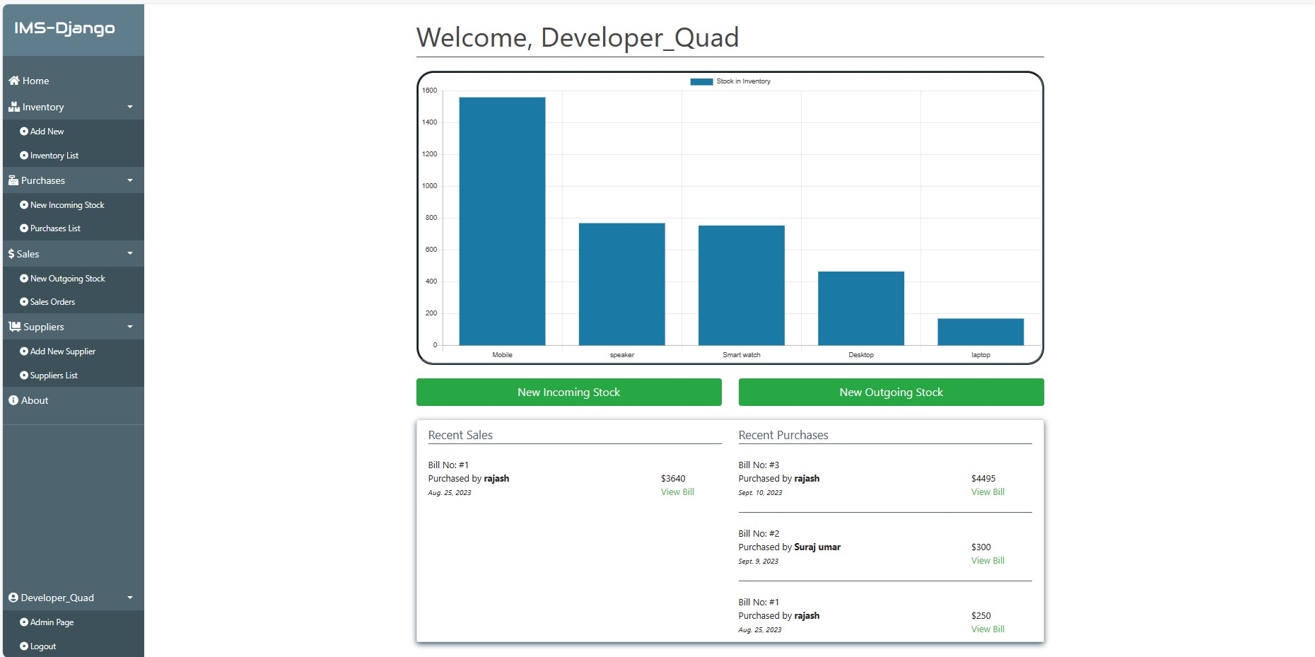

**Image1**: Home Page of inventory management system.

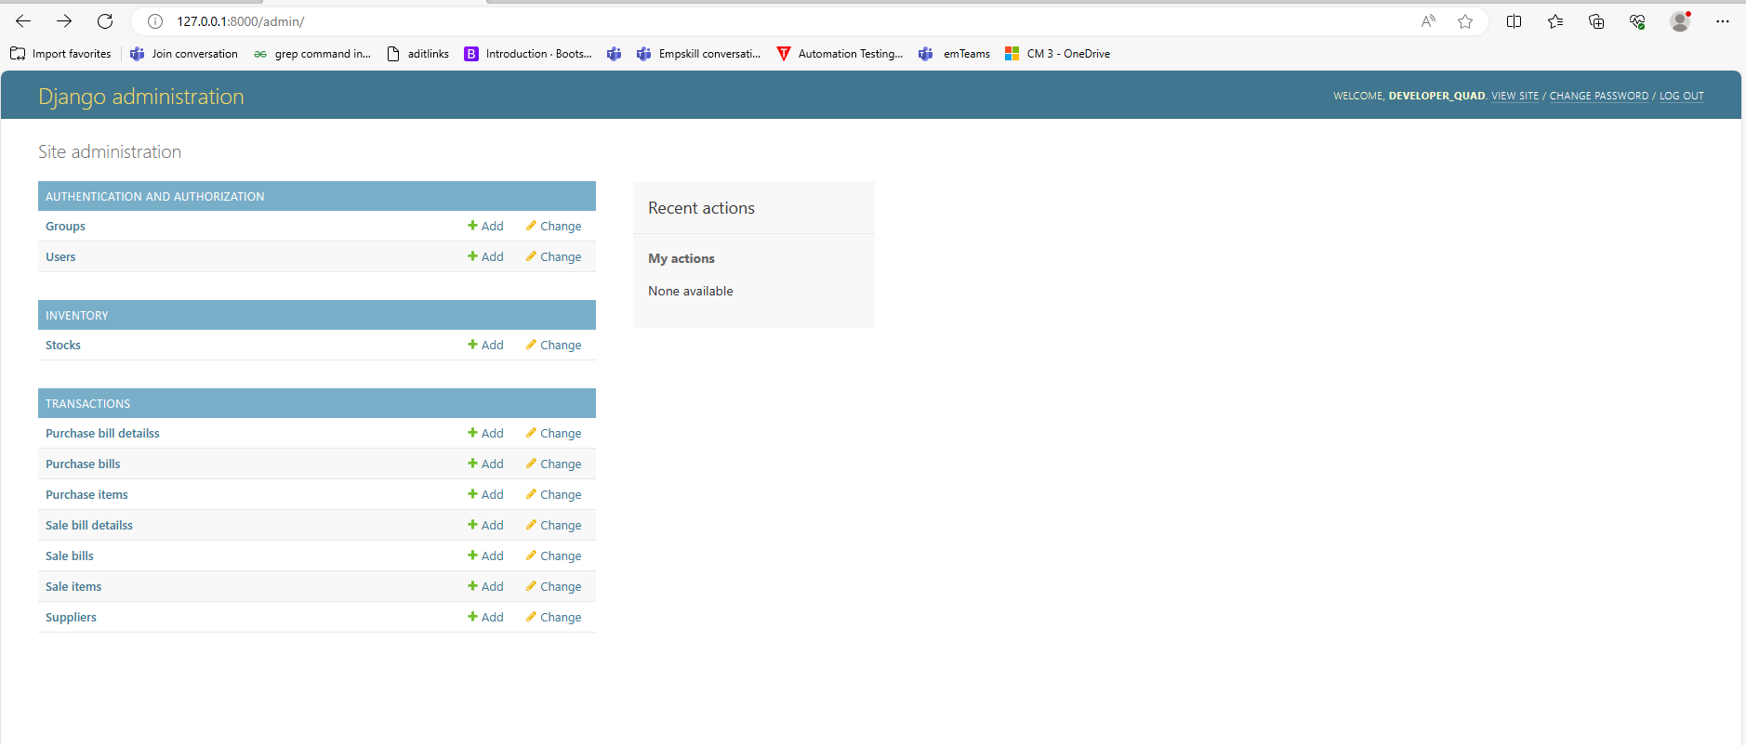

**Image2**: Django administration of inventory management system.

**FUTURE SCOPE**

The future scope of an inventory management system can be quite extensive, as it can benefit from advancements in technology, changes in business practices, and evolving customer expectations. Here are some potential areas of future development and expansion for an inventory management system:

1. Integration with Emerging Technologies:

Explore integration with emerging technologies like blockchain for enhanced data security and transparency in the supply chain.

Consider the use of Internet of Things (IoT) devices for real-time monitoring of inventory levels and conditions (e.g., temperature, humidity).

2. Artificial Intelligence (AI) and Machine Learning (ML):

Implement AI and ML algorithms for demand forecasting to optimize inventory levels and reduce carrying costs.

Utilize computer vision for automated item recognition and barcode scanning.

Develop predictive maintenance models for equipment and machinery used in inventory management.

3. Mobile and Remote Access:

Enhance mobile accessibility for inventory management through dedicated mobile apps or responsive web design.

Implement remote monitoring and management capabilities, allowing users to control inventory from anywhere.

4. Advanced Analytic and Reporting:

Expand reporting capabilities with more advanced analytics, data visualization, and business intelligence tools.

Enable remote assistance using AR for troubleshooting inventory issues.

5. Sustainability and Green Practices:

Incorporate features to track and report on sustainable and environmentally friendly practices in inventory management.

Implement tools for carbon footprint calculation related to inventory and supply chain operations.

6. Enhanced Security and Compliance:

Stay updated with the latest cybersecurity best practices to protect sensitive inventory and customer data.

Ensure compliance with evolving data protection and privacy regulations.

7. Scalability and Flexibility:

Plan for scalability to accommodate growing businesses and evolving needs.

Build a modular and flexible system architecture to easily adapt to changing requirements.

8. Supplier Collaboration:

Enable real-time collaboration and communication with suppliers, allowing for quicker response to changes in supply and demand.

9. Data-Driven Decision Making:

Use data analytic and AI-driven insights to make informed decisions about inventory procurement, storage, and distribution.

10. Environmental Monitoring:

Implement sensors and monitoring systems to track environmental conditions in storage areas, ensuring the quality and safety of products.

11. Customer Self-Service:

Provide customers with self-service portals to track their orders and manage their inventory, enhancing their overall experience.

To stay competitive and meet the evolving needs of businesses, it's essential to continuously adapt and innovate within the inventory management system's scope. Regularly assess emerging technologies and industry trends to identify opportunities for improvement and expansion.

**Conclusion**

In conclusion As you can see the importance of inventory management is very serious, it is one of the most important aspects of any business. The aspect of this part of the business is whether or not you can satisfy the demand of your customers if you aren’t sure if you have all the materials available to make the final product . Without Wheeled Coach©having the proper inventory management they would not be able to supply their customers with their ordered ambulance. And this product is what their entire business is based on, so it is of great importance When they are choosing from the different types of programs or automated systems to help with keeping records accurate, Wheeled Coach©needs to keep in mind that the customer is not concerned with which materials are needed to complete the finished product, but the product is operating as promised based on the contract. This is why they need to make sure that any processes or programs that they do decide to use are going to be beneficial to their needs as well as the needs to service their customers (Warren, 2012). In addition, the plans for the maintenance of having proper inventory levels need to be in place and also adjusted when the company grows and as the business dictates (Thibodeaux, 2014). If Wheeled Coach © implements the new suggestions they will be on the right track to having a well established business.

**Appendix A**

**Screenshot of Project**

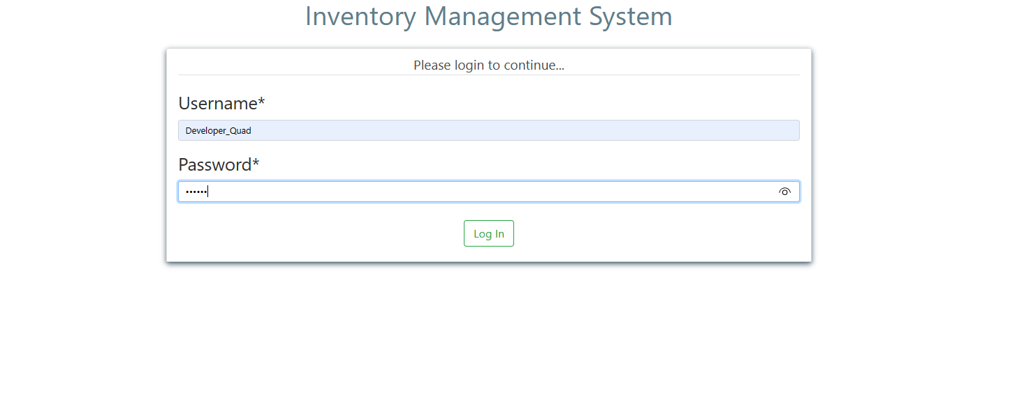

Image1: Admin Login page

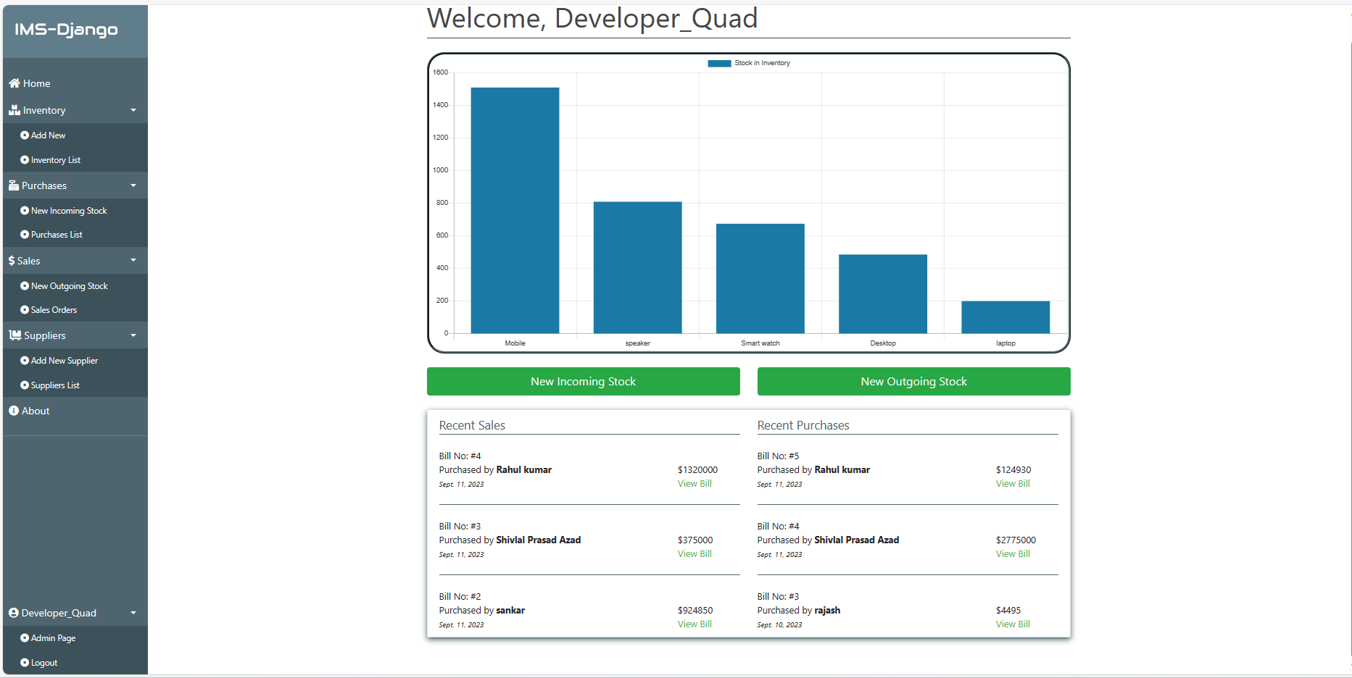

Image2 : Home page of Inventory management project.

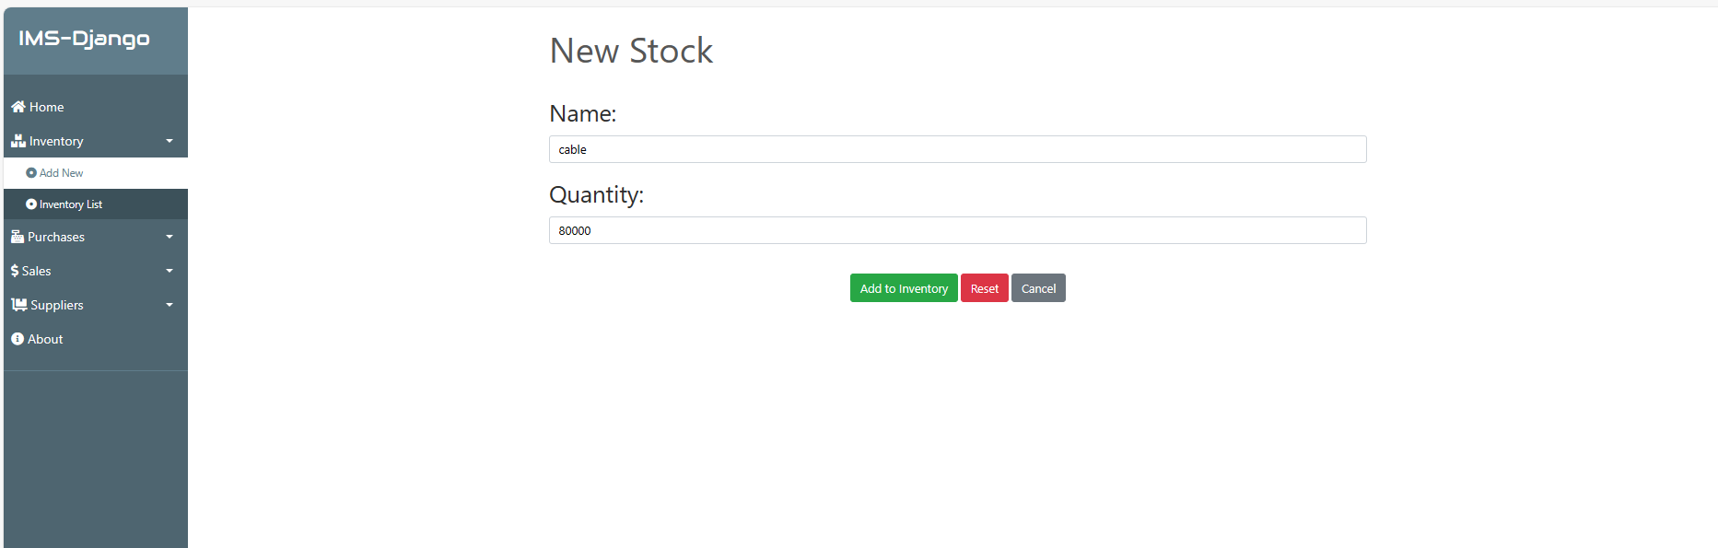

Image 3 : Add new stock

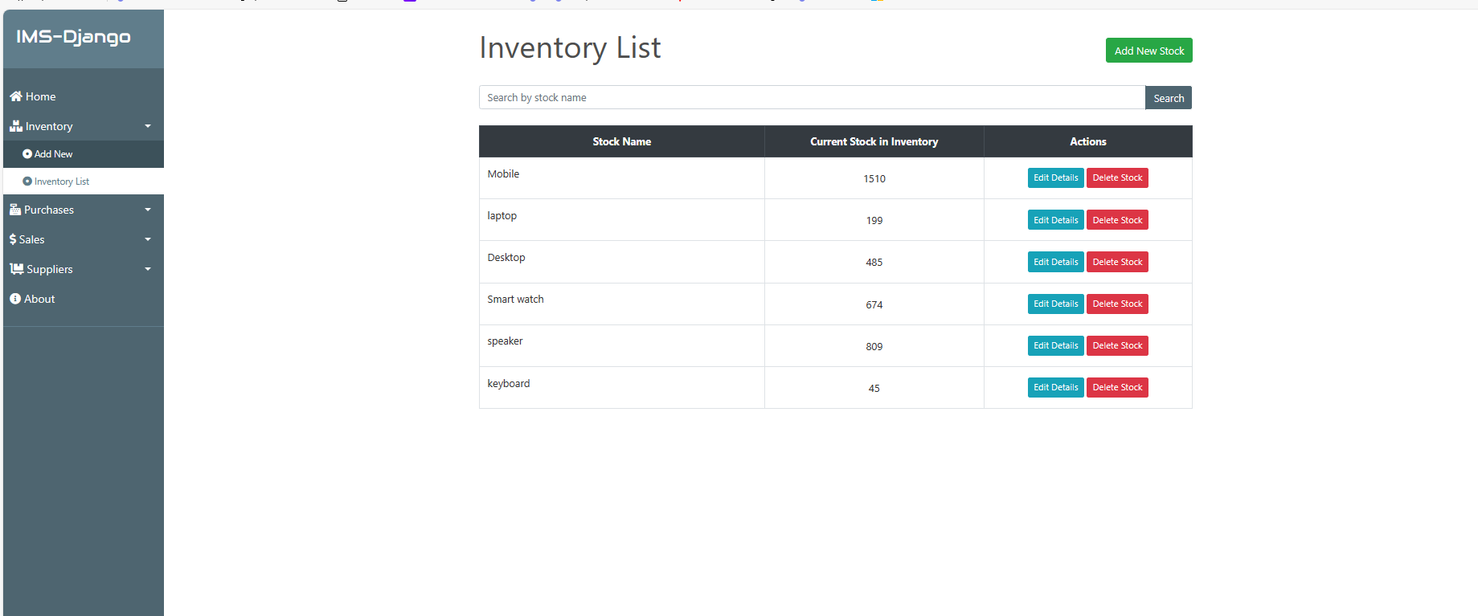

Image 4 : Inventory list item of Inventory management project.

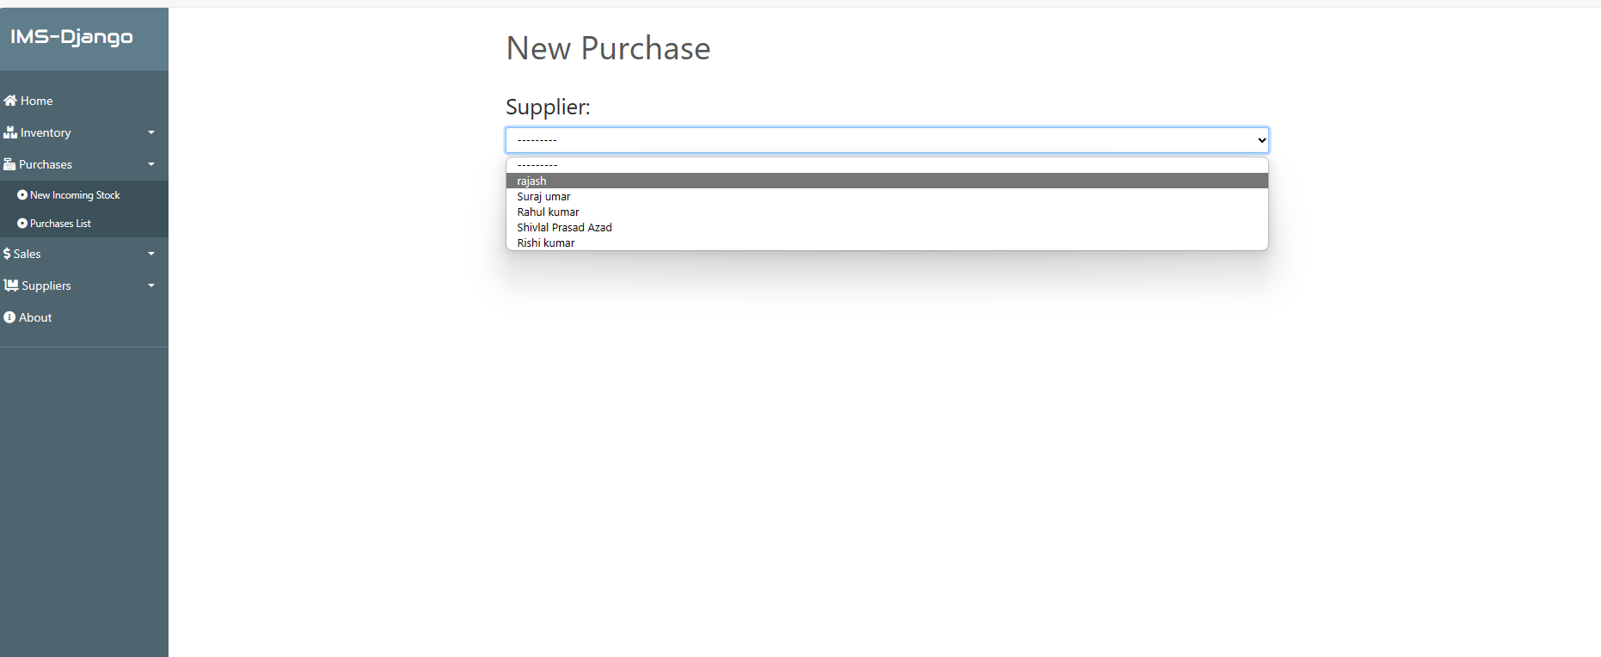

Image 5 : New Incoming stock Purchase .

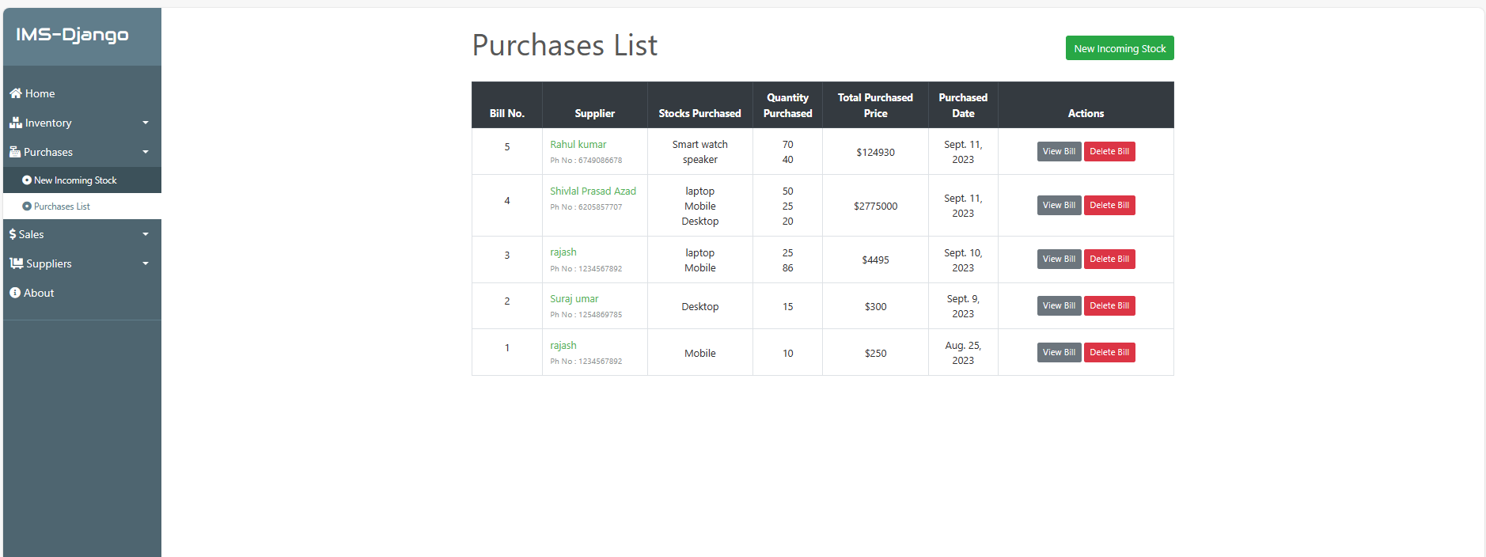

Image 6 : Purchases List of Project

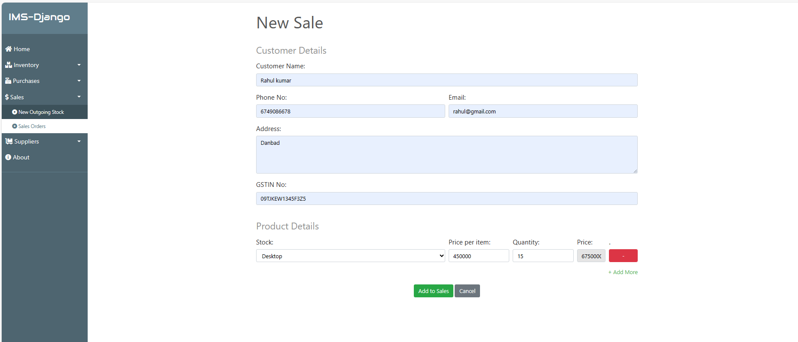

Image 7 : New Outgoing stock project.

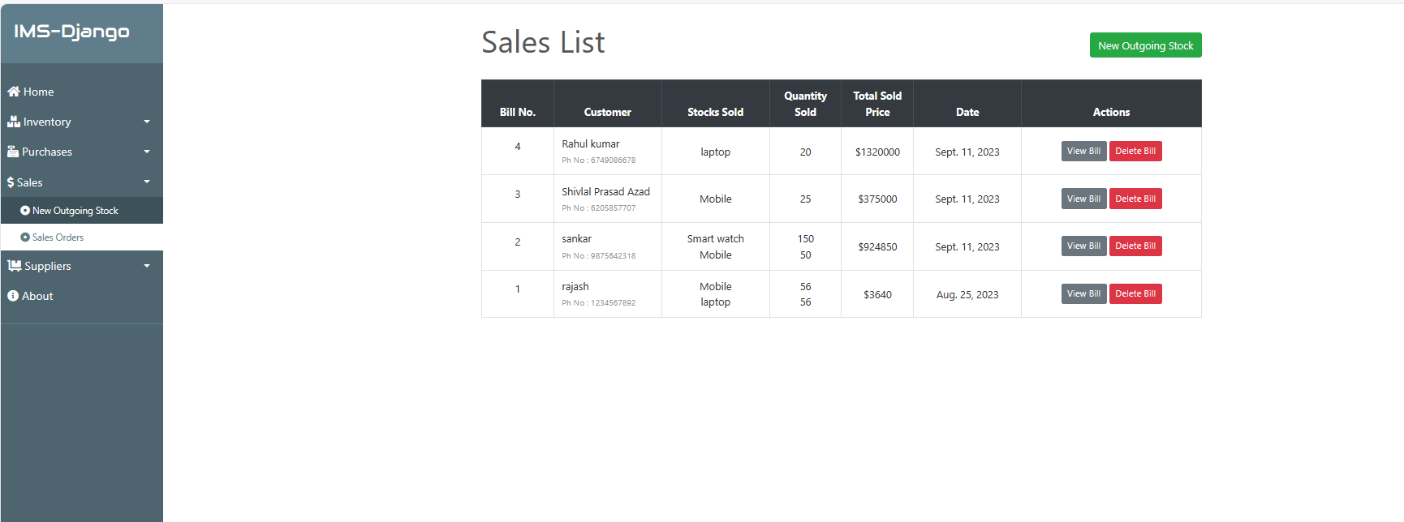

Image 8 : Sales list of project.

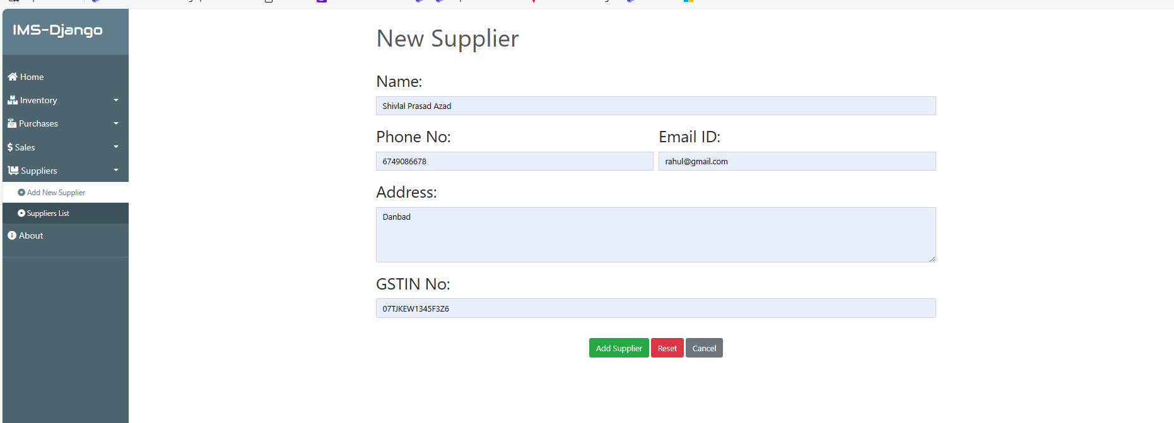

Image 9 : Add new Supplier .

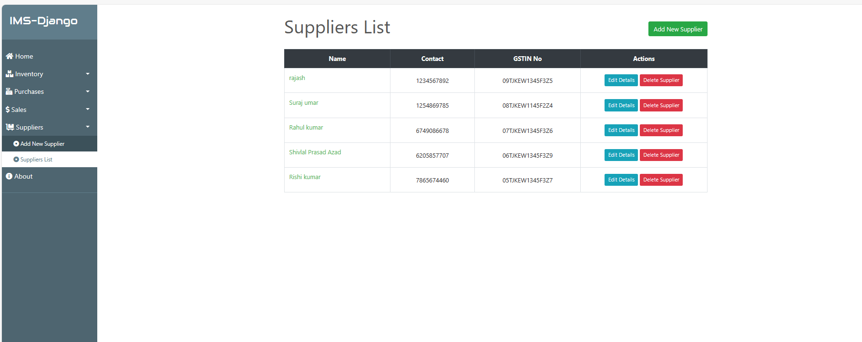

Image 10 : Suppliers list of project.

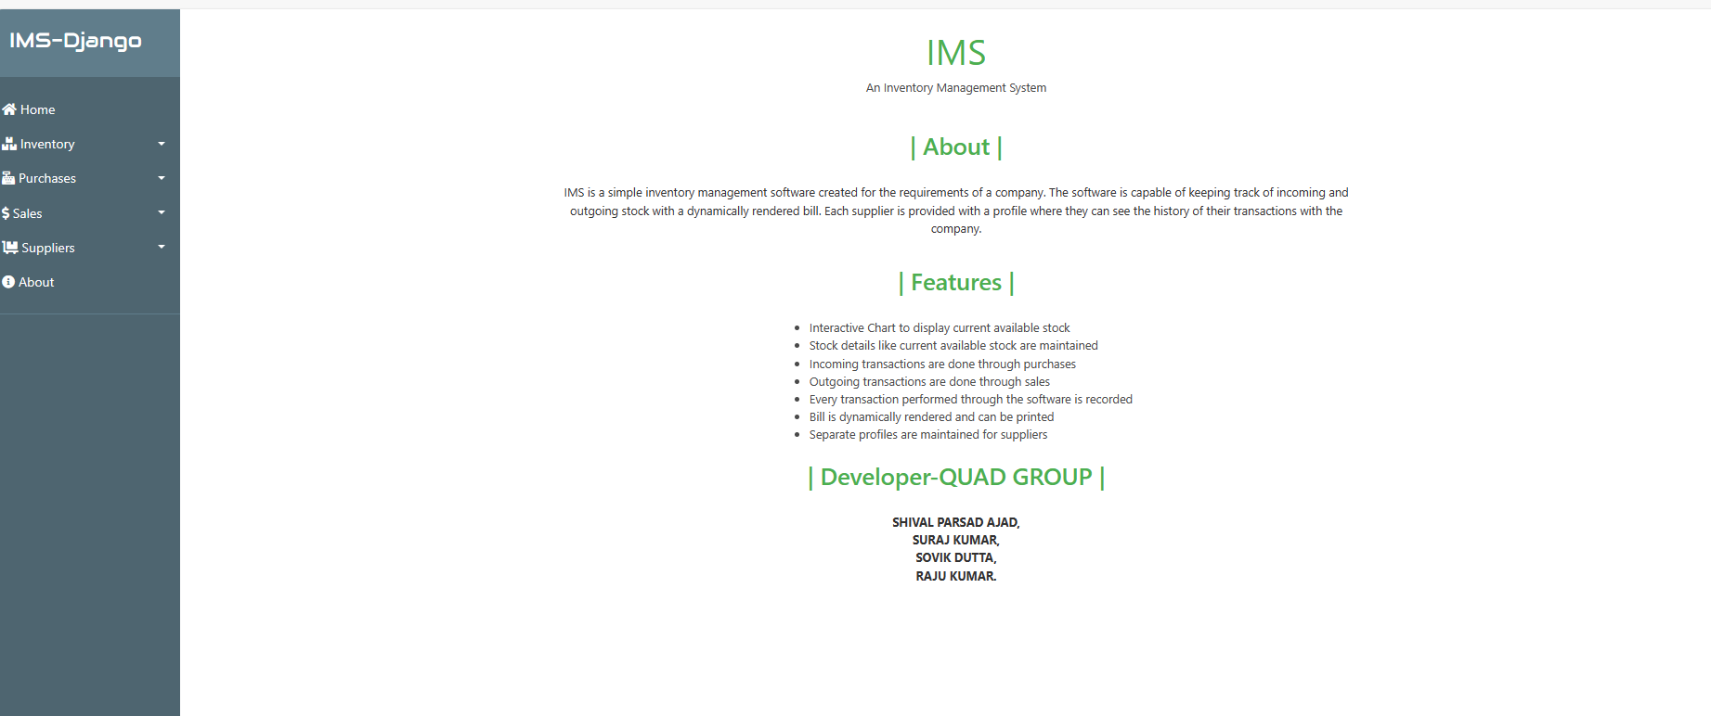

Image 11 : About of Inventory management project.



Image2 : Administration page of project.

**Appendix B**

**Abbreviation**

**References**